Model Design and Application Architecture

Seif ElAnsary†
CSCE Department
The American University in Cairo
ID:900221511
seif_elansary@aucegypt.edu
MagdElDin@aucegypt.edu
MagdElDin AbdalRaaof
CSCE Department
The American University in Cairo
ID: 900211145
MagdElDin@aucegypt.edu

INTRODUCTION
This report will provide information on the implementation choices, APIs, preprocessing components, and retraining method implemented. We will discuss the model back end and the website front end.
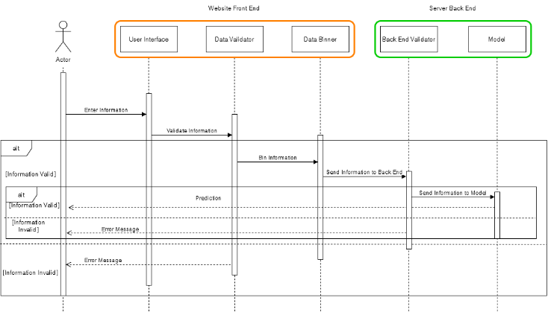 Figure 1
MACHINE LEARNING MODEL

First we implemented the layer class with the identity, sigmoid, and relu activation functions as possible options. Then we initialize the bias as all zeros. Our next step is to define the feed forward and backpropagation steps as we learned. The backpropagation step is where we update our weights and biases as well as defining their rates of change. We also create a dropout layer class to work like it does in keras where some nodes are dropped to avoid overfiting.

For the neural network class called NN, we calculate the mean squared error of the prediction as well as the difference. Furthermore, we use the focal loss function to help avoid overfitting. We have feed forward and backpropagation functions here to call upon the appropriate functions for every layer in the neural network. The feed forward and backpropagation are repeated for as many epochs as defined. We also have a function for updating the weights for online learning. It takes the new data and runs feed forward and backpropagation once and then updates the weights and biases based on the difference. The update only running them once is to allow for the update process to be fast instead of having to wait on multiple epochs. Prediction is just running the input through the feed forward network with dropout layers disabled to match keras.
For the general setup, we read a file called columns.txt that has a list of expected columns in the input. Furthermore, we have a function that takes the JSON sent from the application and turns it into a list that can be more easily used. The function that checks data ensures that the JSON has the correct number of objects and that they are all Boolean. The server starts with reading the dataset along with any data collected from user input and then training the model from scratch where our model’s layers match the one detailed in the prior phase. Afterwards, the model has 2 api calls that can be used, one takes user input and predicts if they have diabetes or not, and the other is to collect user feedback on whether the prediction was accurate or not. The prediction call returns the prediction along with the probability of diabetes. The feedback call retrains the model upon collecting the ground truth since now we have a new data point. The new data is appended to the original data frame and saved as a csv.
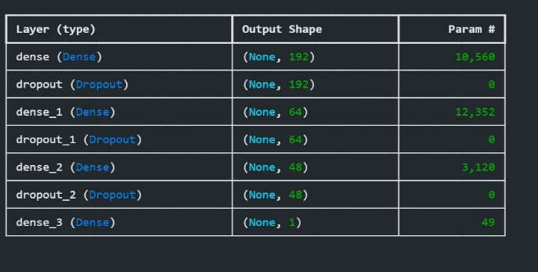
Figure 2
Each dense node is as we studied ANNs in class, completely connected to all prior nodes. The dropout nodes, however, drop some of the connections to avoid overfitting.
The advantage of choosing a neural network is that it was one of the better performing approaches and that its feed forward and backpropagation system helps account for different data instances. Furthermore, the ability to use focal loss helps eliminate the issue of the minority class being ignored. On the other hand, it is more complex to build and train compared to other machine learning approaches.

APPLICATION ARCHITECTURE

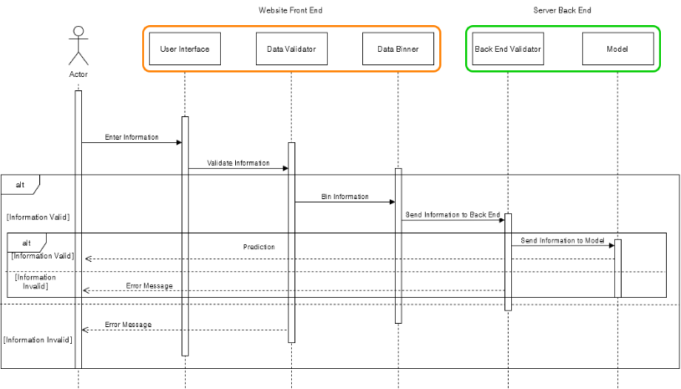
Figure 2

Our application is separated into 2 parts. The first part is the front end, and the second part is the back end.
The front end is responsible for collecting data from the user and validating it. If the data is valid, it is binned and sent to the back end to create a prediction. If it is not, the user is given an error message explaining which input caused the error message.
The front end is going to be in the form of a website developed using the NEXT.js framework. It will contain fields asking the user for the information. To begin, the user will choose using radio buttons for most fields since the fields are binary. For the BMI, general health, age, education level, and income inputs, they will select from a drop-down menu the range they fall under.
Once the data has been entered, the appropriate fields in the input vector are marked with 1 depending on the user’s choices. The data is then sent as a JSON object to the model’s backend using an API call. When the prediction is received, it is displayed to the user.
The backend will be written in Python and will implement the machine learning model discussed in the previous part. The Flask API will handle incoming prediction requests. Data will be validated in the backend as well just in case it got corrupted or tampered with during transfer. If the data is faulty, a return API call is sent to indicate an issue. The data is then used by the model to predict whether the user has diabetes based on the data sent. The prediction is sent as another JSON object to the user through an API call and the user receives their prediction. The input data and prediction are saved on the back end and after every 10 predictions, the model is retrained on the collective data, both new and old. The data collected from user input is saved in a separate csv file.

